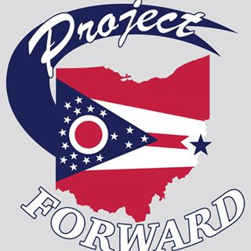

Tailgate in Garden
Winterfest Committee Meeting
08/30/2018
Committee Members Present:

Chris Cleary
Betty Suto
Marian Klier
Missy Yeso
Bill Suto
Anthony Orisini
Rev. Webster
Katie Kendall
Lanie Suriano
Linda Suriano

Event Dates: October 5, 2018
Farmers Market: 12:00pm-4:00pm Event: 4:00pm-11:00pm (Game is 7:00pm – 9:00pm)

- Booster Mom’s are having a tailgate at the Rec center the weekend before ($25.00 a ticket, per person)
- Beer Application – Chris is working on the Beer application, he is just waiting for a PF signature, Dan and Police Chief (4-11:30) .
- Location of the event will be where the farmers market is and the ‘Good neighbor Garden’
- Using the 8 cases we already have, Chris is arranging with Muxie’s. Will have a cider beer =)
- We are selling wristbands for $1.00

- The Grace Presbyterian is going to have a bake sale

- We do have the 3-sink compartment ( at the Wheelhouse/Church)

- Menu:
  - Hotdogs
  - Hamburgers
  - Brats (Peppers/Onions) – 4 cases at the hospital in the freezer
  - Bags of chips (Sams Club)
Condiments ( Mustard, Ketchup, Sourkraut, Relish)

- Entertainment:
  - Broadcast on the radio – Check with media (Karin J)
  - Shannon Cantebary - Dan will contact

- Tents:
  - Will just use the PF tents that were just purchased

- Shirts:
  - 9 for “No place like home” with “tailgate in the garden” on the back
  - We are contemplating making both shirts to sell

- Advertising:
  - Newspapers
  - Make a banners to have it hung up in town
  - Bill will bring up at the school board meeting about advertising to send home

- Activities:
- Corn Hole
- Beer Pong/Flip Cup
- Hillbilly Golf

- Ponchos:
  - Oriental Trading ( Missy) - she will check colors

Melissa made a motion to pay $474.00 to Total Sports Connections for Tailgate in the Garden t-shirts

