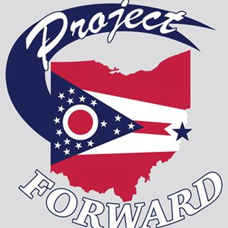
Meeting Date: 9/20/2018 Time: 9:00 am Location: Webster Hall

In Attendance:
Bill Webster ( President)

Anthony Orsini

Rita Randall (Treasurer) Betty Suto
Katie Kendall (Secretary) Chris Cleary
Missy Yeso

The Meeting was called to order at 8:30am by Bill Webster

- The October Project Forward meeting is October 10th (Wednesday) at the Elks
- Establishing a Budget for Winterfest
  - Rita will go back and check the receipts from last year.
  - Chris is making a motion that we start with $5,000.00 as start up to pay expenses/out of pocket
    - Betty second the motion
    - All in Favor

- Chris is making a motion adjourn the meeting
- Rev. Webster second the motion
Meeting was adjourned at 8:58.

