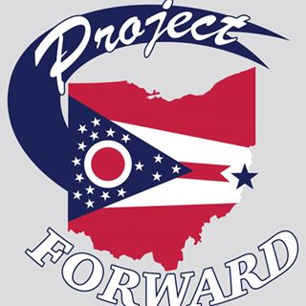
In Attendance:
Rev. Webster Missy Yeso
Chris Cleary
Linda Brown
Katie Kendall
Anthony Orsini
June 12, 2019
Executive Meeting
Minutes:
- Rev Webster: Called meeting to order at 5:32pm

Committees:
Farmers Market (Chair): Set for:
July 11th
August 8th
September 12 (4:00-8:00)
October 10th (4:00-7:00)

We need to decide who is heading this up, and what we are doing for this.

- Linda made a motion that only PF executive board members/officers are allowed to speak at Media events and or council meetings on behalf of Project Forward.
  - Anthony second this motion, all were in favor.

